# 1.

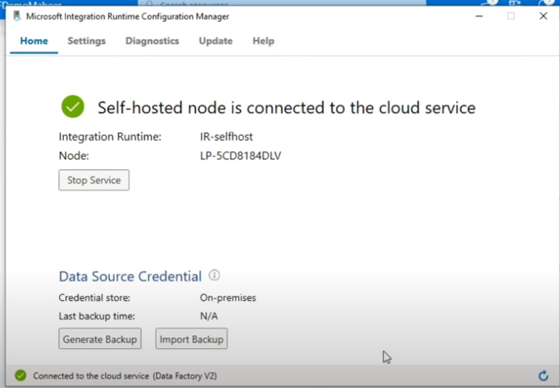

# 2

{

"name": "SftpLinkedService",

"type": "Sftp",

"properties": {

"typeProperties": {

"host": "your-sftp-server-address",

"port": 22,

"userName": "your-username",

"password": {

"type": "SecureString",

"value": "your-password"

}

}

}

}

# 3.



# 4.

